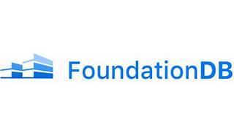

FoundationDB

Explore

**FoundationDB** is a **free and open-source multi-model distributed NoSQL database** developed by Apple Inc. with a shared-nothing architecture. [The core database exposes an ordered key–value store with transactions, and additional features are supplied in “layers”](https://bing.com/search?q=foundationdb+database) [1](https://bing.com/search?q=foundationdb+database)[2](https://en.wikipedia.org/wiki/FoundationDB).

Here are **five reference links** where you can learn more about FoundationDB:

1. [**FoundationDB Official Website**](https://www.foundationdb.org/): Get started with FoundationDB, explore its multi-model data store, and learn about its scalability and fault tolerance.
2. [**Wikipedia: FoundationDB**](https://en.wikipedia.org/wiki/FoundationDB): Dive into detailed information about FoundationDB’s architecture, features, and use cases.
3. [**FoundationDB Architecture and Use Cases**](https://www.xenonstack.com/blog/foundationdb-architecture): Understand the distributed nature of FoundationDB and how it handles large volumes of structured data across clusters.
4. [**FoundationDB on dbdb.io**](https://dbdb.io/db/foundationdb): Explore FoundationDB as a distributed non-relational database that supports ACID transactions and OLTP workloads.
5. **FoundationDB GitHub Repository**: Access the open-source code, contribute to the community, and learn from the source itself.

Feel free to explore these resources to deepen your understanding of FoundationDB! 🚀